DATA STRUCTURES FOR DETECTION OF ROYA IN COFFEE PLANTS
Nayibe Tatiana Vélez David  Universidad EAFIT  Colombia  ntvelezd@eafit.edu.co | Alejandro Fernández Restrepo  Universidad EAFIT  Colombia  afernader@eafit.edu.co | Adelaida Maldonado Esguerra  Universidad EAFIT  Colombia  amaldonade@eafit.edu.co | Mauricio Toro  Universidad EAFIT  Colombia  mtorobe@eafit.edu.co

ABSTRACT

The objective of this report is to analyze and find alternative solutions to the problem related to the cultivation of caturra coffee. This aims to seek control of the plague called Roya, which is attentive to the realization of a good harvest and the loss of products, due to its late diagnosis. What is sought is to find a data structure that allows constant monitoring of the sowing to detect if the crop is being affected by Roya.

KEYWORDS
Data structure, algorithms, runtime, complexity, memory, BigO notation, decision trees.
KEYWORDS OF THE ACM CLASSIFICATION
Software and its engineering → Software creation and management → Designing Software → Software implementation planning → Software design techniques.
Software and its engineering → Software creation and management → Software verification and validation → Operational analysis
Theory of computation → Design and analysis of algorithms → Data structures design and analysis → Sorting and searching
Theory of computation → Design and analysis of algorithms → Data structures design and analysis → Data compression.

2. INTRODUCTION

At present, technology has become a pillar for humanity, because with the implementation of this one seeks an advance, making objects more useful and conducive to the evolution of society.
One can take as an example, the implementation of sensors and data structures that allow the control of caturra coffee crops, preventing pests, especially the rust that is most likely to be present in this type of crop, be the causing damage and loss of products. In this way, what we want to achieve is to give constant control and monitoring of what is present in the crops through technology, which will allow their evolution and prevention of damage.
2. PROBLEM
Design an algorithm with decision trees for the detection of rust in coffee crops by obtaining crop data, such as pH, soil temperature and humidity, lighting, humidity, and ambient temperature. The main objective of the algorithm will be to identify the physicochemical variables of the crop to identify the state of rust in it.

This problem derives other implications such as: obtaining and analyzing the data, verifying the results of the algorithm with the current state of the crop, implementing the solution to real cases and other problems that will occur before and after the creation of the algorithm. The resolution of this problem will allow large coffee crops to have a good development, pest control and reduction of product loss; thus facilitating the export of coffee and continuing to consolidate Colombia as one of the countries with the best production of it.

3. RELATED WORK

3.1 ID3 ALGORITHM

This algorithm is based on the theory of computing and aims to build a decision tree, based on classification, using the most important attribute for the selection of the following attributes, based on the one that has the most important information.

[1] This algorithm is based on mathematical and probability techniques and also introduces a concept: entropy (a measure of uncertainty); The latter is in charge of choosing the attribute that is most likely to be selected.

The decision tree is composed of nodes: root and terminals.

[2] An ID3 problem can be defined by:

• Inputs: These are examples described through pairs (attribute-value)

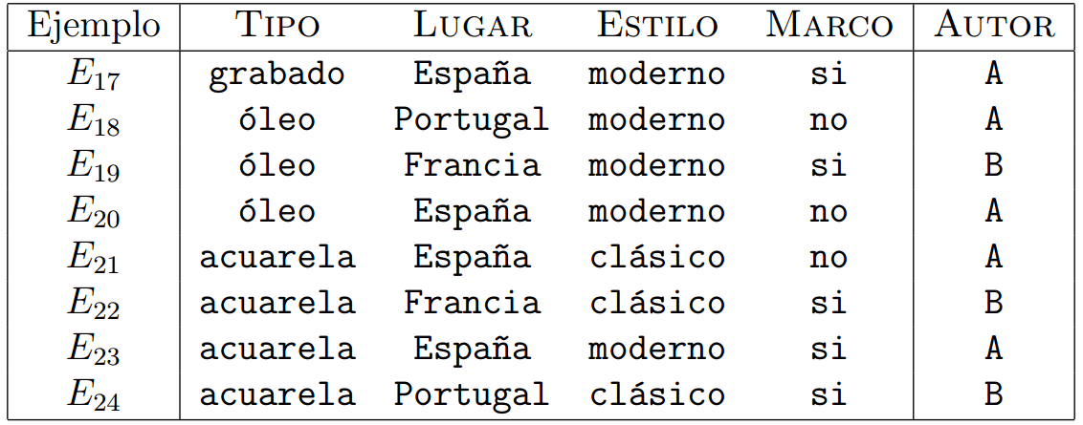
• Exits: It will be the tree built with the classification of examples to the class that should be part.

[3] Ross Quinlan defines the scheme of the ID3 algorithm, which adopts the following:
1. Calculate entropy for all classes.
2. Select the best attribute based on entropy reduction.
3. Iterate until all objects are classified.

Basically, this algorithm aims to classify insufficient order the information sufficient to achieve an interpretation of problems, to minimize tasks.

3.2 C4.5

It is an algorithm used to create a decision tree, these trees can be used for classification and that is why it is referred to as a statistical classifier.

This algorithm was developed by JR Quinlan and was an extension (improvement) of the ID3 algorithm.

When creating a decision tree, this algorithm considers all the possible tests that can be divided from the data set and selects the test with the highest information gain.

This algorithm is mainly used in mining and data analysis, apart from this algorithm it creates and analyzes decision trees in a more efficient way than other algorithms and reduces data loss.

[4] CHARACTERISTICS OF ALGORITHM C4.5

• It allows to work with continuous values ​​for the attributes, separating the possible results in 2 branches Ai <= N and Ai> N

. • Trees are less leafy since each leaf covers a class distribution, not a particular class.

• Use the "divide and conquer" method to generate the initial decision tree from a set of training data.

• It is based on the use of the gain ratio criterion, defined as I (Xi, C) / H (Xi). In this way, it is possible to avoid that the variables with the greatest number of possible values ​​benefit from the selection. • It is Recursive.

3.3 CART

[5] Decision trees are mostly used in machine learning, modeling techniques, and problem classification, they are also used as a way of predicting data by analyzing and verifying data entry.

This algorithm has been used mainly in advertisements and advertisements in social networks through the analysis of the databases of these networks, using user data such as age, type of user and can even use the average salary of the users.

[6] Other application sectors are:
-Insurance industry
- fraud detection
-optimization of campaigns
-among others

CART proposes to segment the database until obtaining a tree structure as complex as possible

3.4 SLIQ

[7] Sliq is a decision tree algorithm used for the classification and analysis of massive amounts of data and also for mining data in databases.
In large amounts of data the classification and analysis of these are very important to maintain order, this problem is where sliq is born as an algorithm that solves these problems.

For the creation of these trees, the algorithm mainly takes into account two factors, first the evaluation and the separation by types of the data and secondly the creation of partitions of data types.

Sliq is an algorithm that is capable of handling both numbers and different types of variables to create the decision trees on them.
4. TITLE OF THE FIRST DATA STRUCTURE DESIGNED

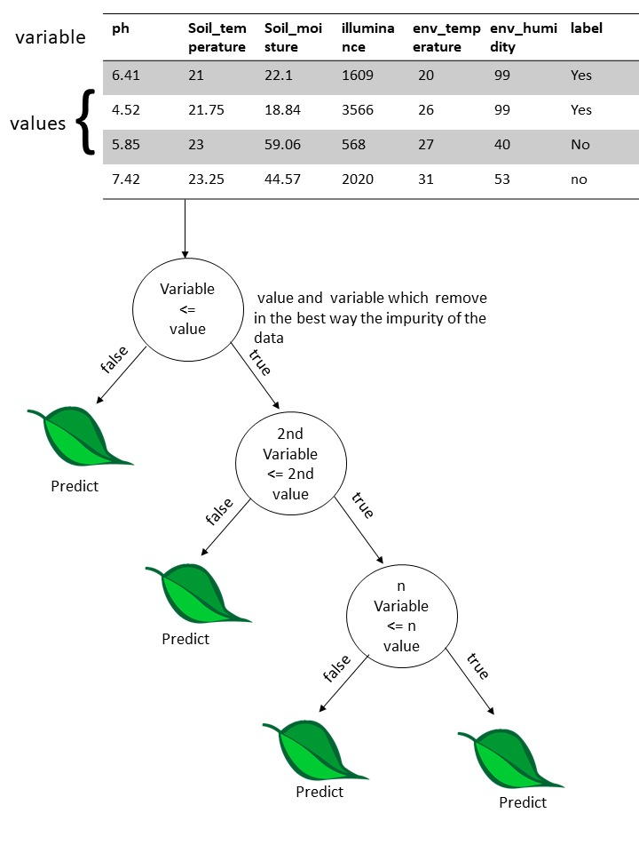
Figure 1: Decision tree based on CART, to publicize the presence of rust in a coffee crop.

4.1 DATA STRUCTURE OPERATIONS

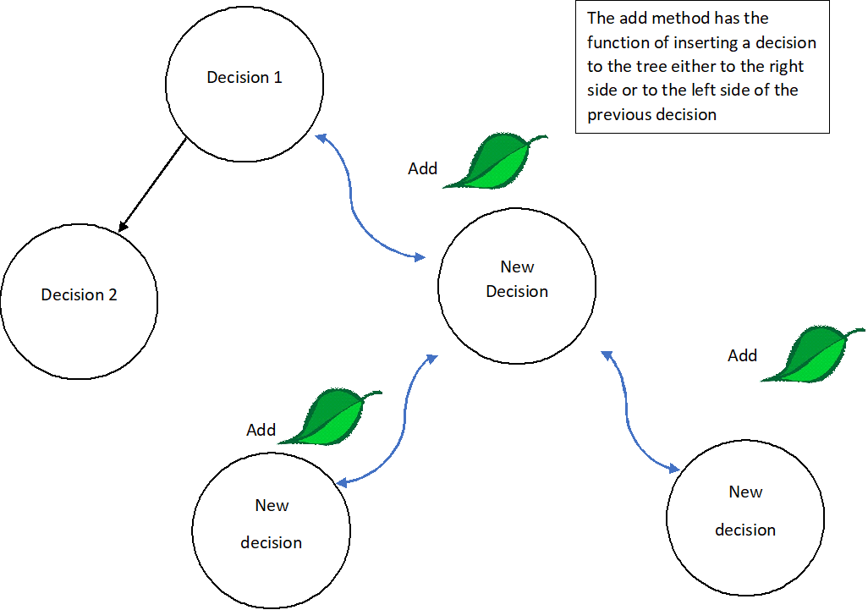

Figure 2: Representation of the insert operation.

[8] 4.2 DATA STRUCTURE DESIGN CRITERIA

We have chosen, to perform the decision tree algorithm, the CART model that is understood as Classification And Regression Trees. This model can be used as well as for the predictive classification or regression of models. The representation of the CART model is binary where each root represents a variable input and at the same time a point of division in that variable. The outputs nodes of the tree are its leaves that are used to make the prediction. The selection of which input variable to use and the cut-off point is chosen using an algorithm to minimize a function. Tree construction is completed using a predefined stop criteria, such as a minimum number of training instances assigned to each leaf node in the tree. There must be a special order for the order of the variables, otherwise the tree would not be effective and the answers would be different each time. For this, a numerical procedure is used where all the values ​​are aligned and different dividing points are tested using a cost function in this case gini. The division with the best cost (lowest cost) is selected. Thus, this model fits perfectly and in what we want to do in the prediction of the rust where to know the order of the roots, we will previously find with a function the impurity of each variable and its respective value which will also be found using the formula of impurity After having the impurity value of each variable, they will be ordered from least to greatest and that will be the order of the roots. At the end of all this when a new plant is entered through the decision tree, the rust prediction will be reached.
4.3 COMPLEXITY ANALYSIS
METHOD | COMPLEXITY
Read | O(n)
Save | O(n)

Figure 3: Complexity of the algorithms of the different methods.
4.4 PERFORMANCE TIMES

 | Archive
Reading | 10ms

Figure 3: Time it takes for algorithms to run.

4.5 MEMORY

 | Archive
Reading | 1 MB
Figure 4: memory space
4.6 ANALYSIS OF THE RESULTS

Autocomplete Structure | Matrix
Path | 10 ms
Size | 1 MB
Figure 5: Union of the results for a previous analysis.

REFERENCES
[1] [3] Wikipedia. Árbol de decisión (modelo de clasificación ID3). Retrieved August 11 2019. From http://bit.ly/2N0pEoF
[2] Fernando Sancho Caparrini. Aprendizaje Inductivo: Árboles de Decisión. 26 of December de 2018. Retrieved August 11 2019. From http://bit.ly/2MZnDJ9
[4] Espino, Tijerina, Cedano, de la Fuente , Pérez, Chiñas. ~ ALGORITMO C4.5 ~ . November 2005. Retrieved August 11 2019. From http://bit.ly/2yTgnq2
[5] Amir Ali. Decision Tree (CART) Algorithm in Machine Learning. July 2018. Retrieved August 11 2019. From http://bit.ly/2KIJdyG
[6] Jorge Martín Arevalillo. Data Mining con Árboles de Decisión. Retrieved August 11 2019. From http://bit.ly/2Z1BnWa
[7] Manish Mehta, Rakesh Agrawal and Jorma Rissanen. SLIQ: A Fast Scalable Classifier for Data Mining. Retrieved August 11 2019. From http://bit.ly/2H1rmSD
[8] Jason Brownlee: Classification And Regression Trees for Machine Learning. Retrieved April 8 2016.From http://bit.ly/33dgucX

